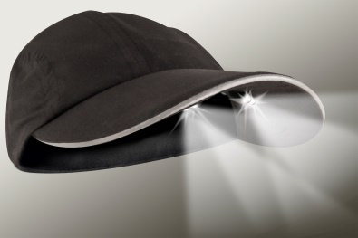
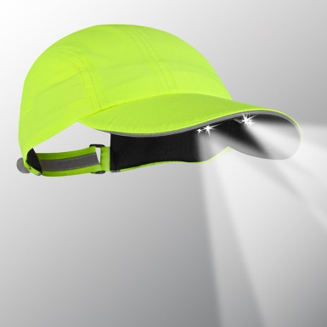
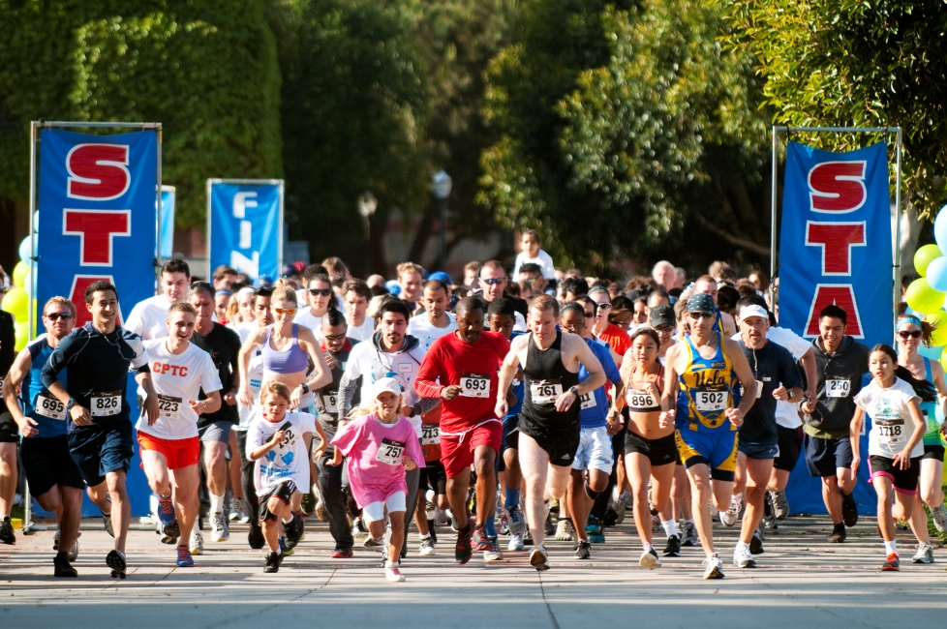

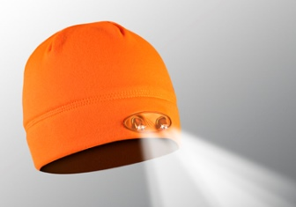
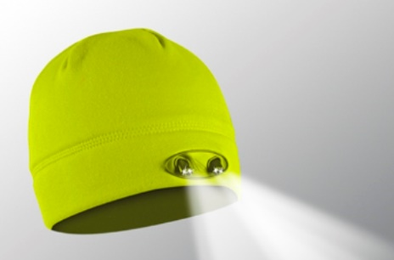

VISIT OUR WEBSITE WWW.PANTHERVISIONPROMO.COM
TO SEE THE FULL LINE OF LIGHTED PRODUCTS
OR CALL 847.783.5900 x 116 FOR MORE INFORMATION

VISIT OUR WEBSITE WWW.PANTHERVISIONPROMO.COM
TO SEE THE FULL LINE OF LIGHTED PRODUCTS
OR CALL 847.783.5900 x 116 FOR MORE INFORMATION

ASI 75825 SAGE 68668 PPAI 318255

VISIT OUR WEBSITE WWW.PANTHERVISIONPROMO.COM
TO SEE THE FULL LINE OF LIGHTED PRODUCTS
OR CALL 847.783.5900 x 116 FOR MORE INFORMATION

VISIT OUR WEBSITE WWW.PANTHERVISIONPROMO.COM
TO SEE THE FULL LINE OF LIGHTED PRODUCTS
OR CALL 847.783.5900 x 116 FOR MORE INFORMATION

VISIT OUR WEBSITE WWW.PANTHERVISIONPROMO.COM
TO SEE THE FULL LINE OF LIGHTED PRODUCTS
OR CALL 847.783.5900 x 116 FOR MORE INFORMATION

VISIT OUR WEBSITE WWW.PANTHERVISIONPROMO.COM
TO SEE THE FULL LINE OF LIGHTED PRODUCTS
OR CALL 847.783.5900 x 116 FOR MORE INFORMATION

Some of the best training happens before the sun rises and after it sets

There are numerous benefits that accompany a
well-run wellness program. These programs save
money for the company by reduced absenteeism and promote greater productivity. They encourage
employees to be healthier, stronger and be better
able to handle their work/life balance.

Quick dry, light weight microfiber material and
reflective trim in the sandwich and back keyhole on the caps. The beanies feature a moisture wicking
liner. Easy on/off switch provides 48 lumens of useful lighting. Included batteries are easily replaceable.

Add your logo and light up your brand!

Stealth 2575 Runners in Black PR4-142 Yellow PR4-177
Runners/walkers will see and be seen
5K Charity Event?
Wellness Program?

Get the best hats for training
While promoting your brand

Add company information and logo here
Customer friendly website at www.panthervisionpromo.com
POWERCAP® Beanies 3555
Yellow WB-5529 & Orange WB-4546

